**Assignment 3 Use-Case Note App**

The user types in a note into the main text box (txtContent). The note can be multiple lines long. Then the user clicks the save button (btnSave). The user can then type in a new note and hit save again.

Each time the save button is clicked, the note from the text box is added to a string array and to the listView (noteList) in the bottom half of the interface. When the user clicks on a note in the listView the string is loaded up in the text box in the top half of the screen where the user can edit it.

1. 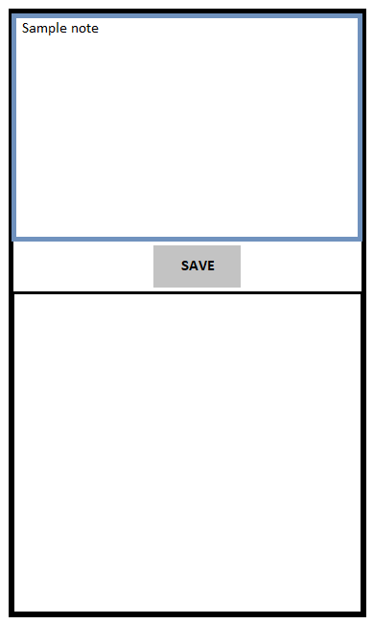User types a note in the text box 2. The user clicks save and the note is added to the listView

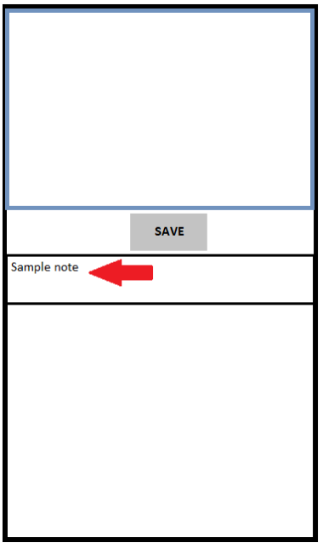

1. The user clicks on the old note and it loads in the text box

